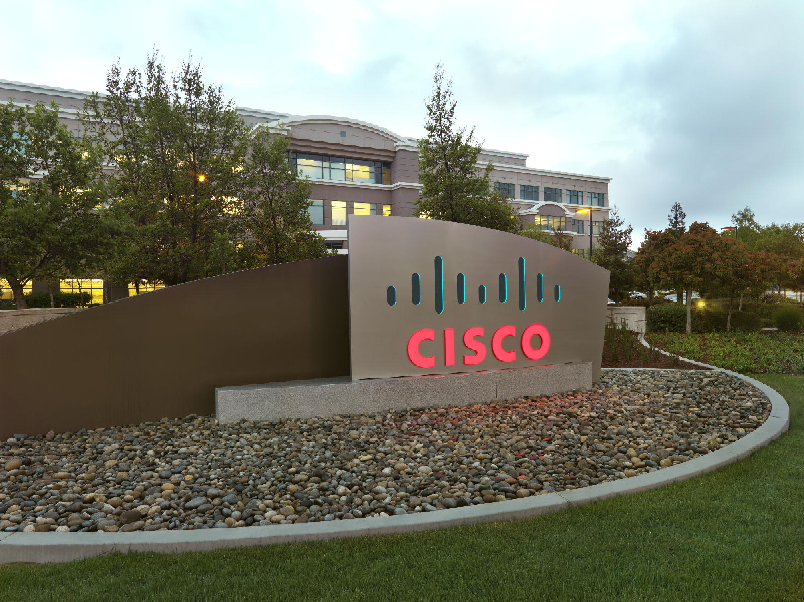

Advanced Service Assets

“PDTool” Promotion and Deployment Tool

PDTool Studio Installer User Guide
Data Virtualization Business Unit Advanced Services
September 2015

TABLE OF CONTENTS
INTRODUCTION 4
License 4
Purpose 4
Audience 5
Platform Support 5
PDTool Studio (VCS Integration) Installer User Guide 6
Pre-Requisite Checklist 6
1. Network Connection: 6
2. JRE7 Installed: 6
3. Version Control System (VCS) Access: 6
4. Pre-Configured PDTool Studio Installer: 6
User Installation Procedure 6
1. Unzip the PDTool Studio Installer Zip File: 6
2. Install Cisco PDTool Studio: 6
3. User Prompts: 7
4. What Gets Executed? 9
5. Logging into CIS Studio “Important”: 10
6. Managing Errors: 10
7. Verify Installation: 10
conclusion 12
Concluding Remarks 12
How you can help! 12

Document Control

Version History
Version | Date | Author | Description
1.0 | 09/18/2015 | Mike Tinius | Initial revision for Installer User Guide

Related Documents
Document | Date | Author
Cisco AS Promotion and Deployment Tool – PDTool Studio Installer Admin Guide | Cisco PDTool Studio Installer Admin.pdf | Mike Tinius

Data Virtualization Business Unit (DVBU) Products Referenced
DVBU Product Name | Version
Composite Information Server | 6.2, 7.0
INTRODUCTION

License
(c) 2015 Cisco and/or its affiliates. All rights reserved.
This software is released under the Eclipse Public License. The details can be found in the file LICENSE. Any dependent libraries supplied by third parties are provided under their own open source licenses as described in their own LICENSE files, generally named .LICENSE.txt. The libraries supplied by Cisco as part of the Composite Information Server/Cisco Data Virtualization Server, particularly csadmin-XXXX.jar, csarchive-XXXX.jar, csbase-XXXX.jar, csclient-XXXX.jar, cscommon-XXXX.jar, csext-XXXX.jar, csjdbc-XXXX.jar, csserverutil-XXXX.jar, csserver-XXXX.jar, cswebapi-XXXX.jar, and customproc-XXXX.jar (where -XXXX is an optional version number) are provided as a convenience, but are covered under the licensing for the Composite Information Server/Cisco Data Virtualization Server. They cannot be used in any way except through a valid license for that product.
This software is released AS-IS!. Support for this software is not covered by standard maintenance agreements with Cisco. Any support for this software by Cisco would be covered by paid consulting agreements, and would be billable work.

Purpose
The User Guide provides a PDTool Studio User with the steps to install PDTool Studio on Windows using the PDTool Studio Installer.
This is the part of PDTool that provides VCS integration with CIS Studio. The other part of PDTool is simply called PDTool and is focused on deployment and testing facilities.
What gets installed?
- Cisco PDToolStudio6.2 or PDToolStudio7.0.0
- VCS Client if the Administrator chooses to pre-configure the \VCSClients folder
Where do the files get copied?
- Recommended default location: C:\Users\%USERNAME%\.compositesw\PDToolStudio[6.2|7.0.0]_[TFS|SVN|GIT|P4|CVS]
  - E.g. C:\Users\user1\.compositesw\PDToolStudio7.0.0_TFS
  - \PDToolStudio – PDToolStudio VCS integration directory
  - \VCSClients – Pre-configured VCS clients are optional if installed elsewhere.
    - \SVN_client – Subversion client
    - \TFS_TEE_client – Team Explorer Everywhere client
    - \GIT_client – Git client
    - \P4_client – Perforce client
    - \CVS_client – CVS client

Audience
This document is intended to provide guidance for the following users:
- For CIS Developers only who have Cisco Studio installed and want to connect to a version control system (VCS) such as TFS or Subversion.

Platform Support
The PDTool Studio Installer is only supported on Windows.

PDTool Studio (VCS Integration) Installer User Guide

Pre-Requisite Checklist
The following is a list the User will need to check before installing for PDToolStudio:

Network Connection:
Each user must be connected to a network and have access to the VCS server.

JRE7 Installed:
JRE 7 (1.7) must be pre-installed on the target computer before installing PDTool. Each user must perform this action.
If Cisco Studio 7.0 is installed, it is possible to utilize that JRE: CIS_HOME\jre or you can use the one installed in the “C:\Program Files\Java\jre7”.

Version Control System (VCS) Access:
Each user must perform this action.
The user must submit a request in advance to their organization to get access to a version control system (VCS) repository prior to installation of PDTool.

Pre-Configured PDTool Studio Installer:
The PDTool Studio Administrator has “pre-configured” the PDTool Studio Installer and provided the location of the zip file to the user.

User Installation Procedure

Unzip the PDTool Studio Installer Zip File:
  - This is the package that the Administrator has “pre-configured” for the organization. Unzip to any directory on your windows machine e.g. [C:\Temp].
    - PDToolStudio6.2_installer.zip
    - PDToolStudio7.0.0_installer.zip
  - Use PKZip and select “Extract Here” which will extract the file to the C:\Temp directory as shown below. If you use the Windows “Extract All”, then it is recommended to remove the trailing folder
    - Location: C:\Temp\PDToolStudio6.2_Installer
    - Location: C:\Temp\PDToolStudio7.0_Installer

Install Cisco PDTool Studio:
- Purpose – The purpose of this is to install the “pre-configure” batch files for your organization so that you have a consistent and uniform configuration across the developer and tester user base.
- Location
  - [C:\Temp]\PDToolStudio6.2_installer\installer
  - [C:\Temp]\PDToolStudio7.0.0_installer\installer
- For any VCS [TFS,SVN,GIT,P4,CVS] Execute:
- Edit: PDToolStudio-VCS.bat and provide any default values that require modification. The variables should have been pre-configured by the PDTool Studio administrator.
- Execute by double-clicking on the following batch file from windows explorer:
PDToolStudio-VCS.bat
  - Acknowledge Cisco Open Source License
  - Follow the “Prompts” section below for detailed information.

User Prompts:
- Purpose – The user is prompted for the following parameters unless this information is provided as parameters on the command line. The default values are provided within the square brackets. Press enter with no input to accept the default value or type your value and press enter.
- Prompts:
Enter I_PDTOOL_INSTALL_SCRIPTS=[%DEF_PDTOOL_INSTALL_SCRIPTS%]:
    - Location of the PDTool installation scripts. E.g. C:\Temp\PDToolStudio7.0.0_installer
License Acknowledgement
- Use space bar to page through license
- Review and acknowledge the open source license [Y].
Enter I_JAVA_HOME=[%DEF_JAVA_HOME%]:
    - I_JAVA_HOME=JRE7 home folder. E.g. C:\Program Files\Java\jre7
Enter I_PDTOOL_DESTINATION_HOME=[%DEF_PDTOOL_DESTINATION_HOME%]:
    - I_PDTOOL_DESTINATION_HOME - The destination home folder for the PDTool installation and associated binaries.
    - TFS: C:\Users\%USERNAME%\.compositesw\PDToolStudio7.0.0_TFS
    - SVN: C:\Users\%USERNAME%\.compositesw\PDToolStudio7.0.0_SVN
    - GIT: C:\Users\%USERNAME%\.compositesw\PDToolStudio7.0.0_GIT
    - P4: C:\Users\%USERNAME%\.compositesw\PDToolStudio7.0.0_P4
    - CVS: C:\Users\%USERNAME%\.compositesw\PDToolStudio7.0.0_CVS
Enter I_PDTOOL_DESTINATION_DIR=[%DEF_PDTOOL_DESTINATION_DIR%]:
    - The destination directory name for the PDTool Studio installation and associated binaries. e.g. PDToolStudio
Enter I_OVERWRITE_DECISION=[N]:
    - This prompt only comes up when the target PDTool directory exists. It allows the user to decide whether they want to overwrite that directory or not. Enter Y to overwrite the existing directory.
Enter I_VCS_TYPE=[%DEF_VCS_TYPE%]:
    - I_VCS_TYPE - The version control type [TFS|SVN|GIT|P4|CVS]
Enter I_VCS_HOME=[%DEF_VCS_HOME%]:
    - This is the location of the VCS script executable. E.g. C:\Users\%USERNAME%\.compositesw\PDToolStudio7.0.0_SVN\VCSClients\SVN_client
Enter I_VCS_REPOSITORY_URL=[%DEF_VCS_REPOSITORY_URL%]:
    - Note: make sure the forward slashes are escaped with 4 slashes: https:////url
    - TFS: The TFS repository URL pointing to the repository collection. e.g. http:////hostname.domain.com/tfs/DefaultCollection
    - SVN: The subversion repository path at trunk or any folder designation within trunk. e.g. https:////svn.hostname.com/svnrepos/myrepo/trunk/main
Enter I_VCS_PROJECT_ROOT=[%DEF_VCS_PROJECT_ROOT%]:
    - E.g. SVN: cis_objects
Enter I_VCS_USERNAME=[%USERNAME%]:
    - This is your user name regardless of whether it is TFS or Subversion and is used to connect to the VCS repository. The user must submit a request to get access to a repository prior to installation of PDTool.
Enter I_VCS_DOMAIN=[%DEF_VCS_DOMAIN%]:
    - When using TFS, include the VCS domain such as “@CORP”. The result for the I_VCS_USERNAME would look like “username@CORP”. When using subversion, put a single space in the domain so that the script accepts this and continues. The script will remove the space later on. The I_VCS_DOMAIN will be automatically appended to I_VCS_USERNAME.
Enter I_VCS_PASSWORD=<type-your-vcs-password>
    - This is your VCS password which will be encrypted.
Enter I_WORKSPACE_NAME=[%DEF_VCS_WORKSPACE_NAME%]:
    - The PDToolStudio VCS workspace name such as SVNsw7 or TFSsw7.
Enter I_CIS_USERNAME=[%USERNAME%]:
    - This is your user name regardless that will be used to connect to CIS.
Enter I_CIS_DOMAIN=[%DEF_CIS_DOMAIN%]:
    - This is the CIS domain which is used by the I_CIS_USERNAME to connect to Composite. E.g. ldap or composite
Enter I_CIS_PASSWORD=<type-your-cis-password>
    - This is your password which will be encrypted.
Enter I_CONFIG_PROPERTY_FILE=[%DEF_CONFIG_PROPERTY_FILE%]
    - This is the default PDTool Studio configuration property file that the user will use to set the context for which VCS environment to connect to. E.g. studio_SVN.properties or studio_TFS.properties.
The variables are displayed
Enter I_VARS_DECISION [Y or N] – If “Y”, then installation commences. If “N” then the user is prompted for the variables again.
Confirmation of the network drive letter is provided
Existing PDTOOL_SUBSTITUTE_DRIVE=<drive_letter>:
--------------------------------------------------------------------------------------
PDTool network substitute drive letter.
Objective: Used to shorten the overall path to workspace folder mainly for TFS.
Do you want to use the substitute drive letter="<drive_letter>:" [Y or N]:
Installation proceeds after this point.

What Gets Executed?
- Copy source files to destination folder
- For TFS only, TFS eula –accept
- Encrypt passwords: C:\Users\%USERNAME%\.compositesw\PDToolStudio<ver>_<vcs>\setMyPrePDToolStudioVars.bat
- Enable VCS: C:\Users\%USERNAME%\.compositesw\<USERNAME>.<domain>.<cishost>.properties
- Initialize workspace (requires the VCS credentials and repository URL).

Logging into CIS Studio “Important”:
  - The developer will use the same host name that was provided by the default “DEF_CIS_HOST” or the prompt “I_CIS_HOST” and the domain “DEF_CIS_DOMAIN” or the prompt “I_CIS_DOMAIN”.
  - The reason is that the combination of the username + domain + exact hostname is used to configure the CIS Studio properties file in the .compositesw directory. This gets used to configure the VCS integration for Studio which is found in Studio under “Edit→Options” tab.

Managing Errors:
  - If there are any errors reported in the scripts especially during workspace initialization, try removing the workspace directory and then re-execute the installation script.
  - If there is an error while trying to create a substitute drive then first trying removing the substitute drive which was identified as available in the script.
    - net use <drive>: /DELETE
  - If Cisco Studio 6 or 7 throws this error during check-in, simply retry the check-in.
    - Encountered a problem during vcs export. C:\Users\%USERNAME%\.compositesw\.vcs_temp_folders\vcs_export.zip (Access is denied)
    - Additionally, you can manually delete the folder “C:\Users\%USERNAME%\.compositesw\.vcs_temp_folders” and try again.

Verify Installation:
  - Open Composite Studio and go to the Edit Menu and then Options
    - Verify that the “Enable VCS” section is set correctly.
    - Example: Your paths may be different depending on the location and VCS type chosen.
vcsIncludeResourceSecurity=true
enableVCS=true
vcsWorkspacePath= C:\Users\%USERNAME%\.compositesw\PDToolStudio7.0.0_TFS\PDToolStudio\TFSsw\cis_objects
vcsScriptFolder= C:\Users\%USERNAME%\.compositesw\PDToolStudio7.0.0_TFS\PDToolStudio\bin
    - Verify that the corresponding property file was created in the file system for “Enable VCS”:
      - C:\Users\%USERNAME%\.compositesw\<USERNAME>.<domain>.<cishost>.properties
    - Alternative approach: Modify with a script
Example:
ExecutePDToolStudio.bat -nopause -enablevcs -winlogin %USERNAME% -user %USERNAME% -domain ldap -host hostname.com -includeResourceSecurity true -vcsWorkspacePathOverride "C:\Users\%USERNAME%\.compositesw\PDToolStudio7.0.0\PDToolStudio\TFSsw\cis_objects"

  - Verify that the workspace was created properly
Example:
C:\Users\%USERNAME%\.compositesw\PDToolStudio7.0.0_TFS\PDToolStudio\TFSsw\cis_objects

  - Check-in a resource
- Locate a single resource within /shared folder structure to serve as an example to test the check-in capability.
- Right-click on the resource and select “Check-in to VCS”
- Type “update” in the box
- Click OK
- A window pops up – scroll to the bottom and look for the word “SUCCESSFUL”
FINISHED

conclusion

Concluding Remarks
The AS Promotion and Deployment Tool is a set of pre-built modules intended to provide a turn-key experience for promoting CIS resources from one CIS instance to another. The user only requires system administration skills to operate and support. The code is transparent to operations engineers resulting in better supportability. It is easy for users to swap in different implementations of a module using the Spring framework and configuration files.

How you can help!

Build a module and donate the code back to Cisco Advanced Services for the advancement of the “AS Promotion and Deployment Tool”.
Printed in USA CXX-XXXXXX-XX 10/11

Printed in USA CXX-XXXXXX-XX 10/11
Printed in USA CXX-XXXXXX-XX 10/11

